MUSCULAR TISSUE

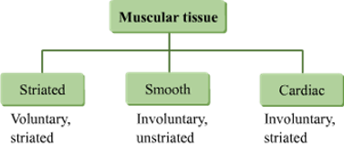

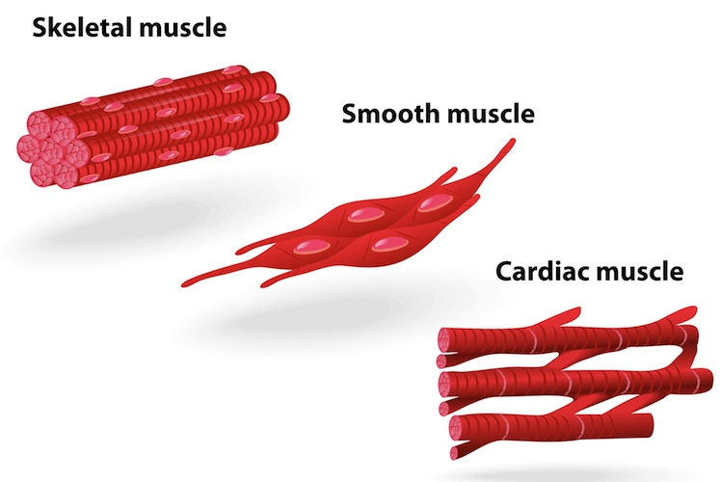

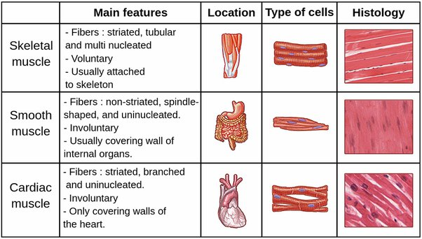
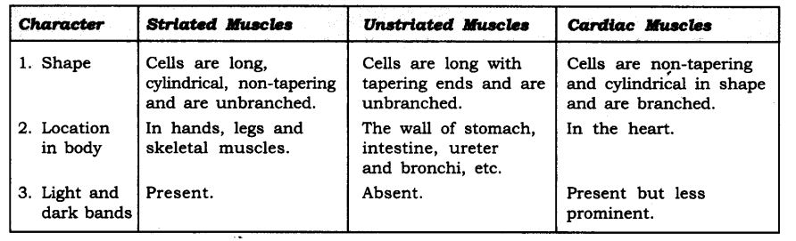
- Striated muscles are voluntary muscles. Muscles that we can move when we want them to are voluntary muscles. These muscles are mostly attached to the bones and help in body movement. So it is also known as skeletal muscles. For example, Muscles present in our limbs are striated muscles.

Structure: The cells of these tissues are long, cylindrical, unbranched and multinucleate.
- Unstriated muscles are involuntary muscles. The movement of food in the alimentary canal or the contraction and relaxation of blood vessels are involuntary movements. It is also known as smooth muscles. For example, Muscles that are found in the iris of the eye, in ureters and in the bronchi of the lungs.

Structure: The cells are long with pointed ends (spindle-shaped) and uninucleate.
LIGHT AND DARK BAND

The striated appearance of skeletal and heart muscle tissue is a consequence of rehashing groups of the proteins actin and myosin that are available along the length of the myofibril.
-The dark band is known as ‘A’ or Anisotropic band which carries Myosin whereas the light bands which carry actin and are called I-band or Isotropic band. Hence called striped muscles thanks to the presence of striations.
-Hence Myofibrils show dark and lightweight bands in Cardiac muscles and striated muscles.

